**WEB APPLICATIN**

### A SUMMER INTERNSHIP REPORT

#### Submitted by

## Kaushal Tiwari

### 210800107046

#### In partial fulfillment for the award of the degree of

## BACHELOR OF ENGINEERING

***in***

**Computer Engineering**

**Vadodara Institute Of Engineering , Vadodara**



## Gujarat Technological University, Ahmedabad

##### [July,2024]



## Vadodara Institute Of Engineering

Vadodara

# CERTIFICATE

This is to certify that the project report submitted along with the project entitled **Internship** has been carried out by **Kaushal Tiwari** under my guidance in partial fulfillment for the degree of Bachelor of Engineering in Computer Engineering, 7th Semester of Gujarat Technological University, Ahmadabad during the academic year 2024-25.

**Prof. Dwiti Pandya** **Prof. Jemisha Patel**

Internal Guide Head of the Department

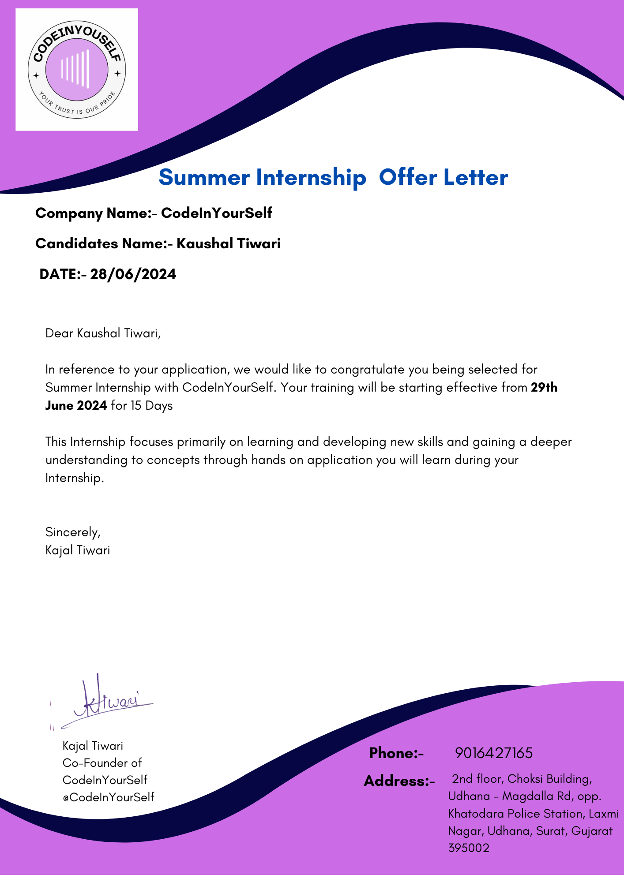

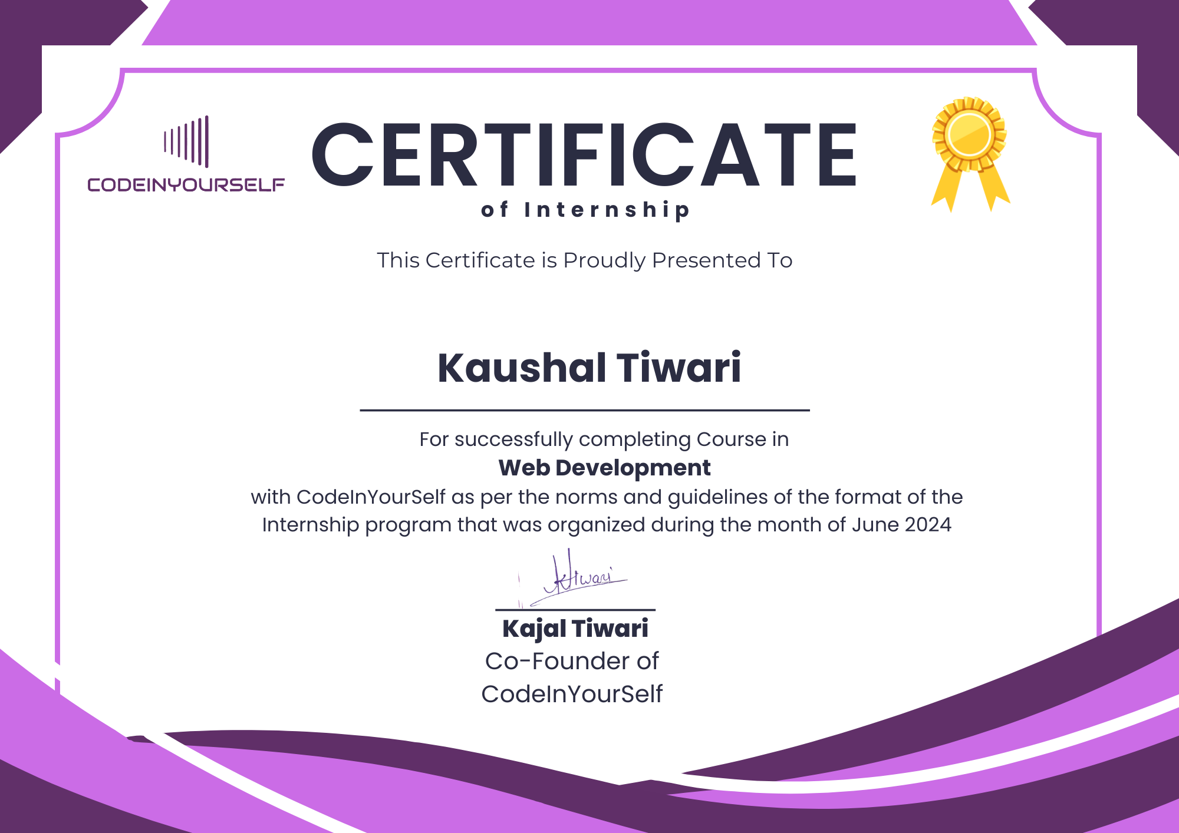



## Vadodara Institute Of Engineering

**Vadodara**

# DECLARATION

We hereby declare that the Internship report submitted along with the Internship entitled **Web Application Development** submitted in partial fulfillment for the degree of Bachelor of Engineering in Computer Engineering to Gujarat Technological University, Ahmedabad, is a Bonafede record of original project work carried out by me / us at CodeInYourSelf under the supervision of Kajal Tiwari and that no part of this report has been directly copied from any students’ reports or taken from any other source, without providing due reference.

Kaushal Tiwari

Name of Student Sign of Student

# Acknowledgement

# First, I would like to the organization (CodeInYourSelf) for giving me the opportunity to do an internship within the organization. I also would like to thank Everyone at company for their patience, encouragement and valuable guidance during the internship. It is indeed with a great sense of pleasure and immense sense of gratitude that I acknowledge the help of these individuals.

# I would like to thank my Head of Department Prof. Jemisha Patel for her constructive criticism throughout my internship.

# I would like to thank Prof. Dwiti Pandya (Internal Guide) for their support and advices to get and complete internship.

# I am extremely great full to everyone who helped me in successful completion of this internship.

# Abstract

*This internship report presents my experiences and insights gained during 15-days internship at* ***CodeInYourSelf*** *in the field of web app development. The primary objective of this internship was to apply theoretical knowledge gained through coursework to real-world projects, enhancing practical skills in web application development.*

*Throughout the internship, I gained practical knowledge of industry-standard development tools, best coding practices, and collaborative workflows, including version control through Git. Additionally, the experience fostered a deeper understanding of user experience (UX) design and responsive web development, with a strong emphasis on creating interactive, scalable, and performance-optimized web applications.*

*The report also highlights the learning process, challenges faced, and solutions implemented during the internship, as well as the professional growth achieved in terms of technical skills, communication, and teamwork. This internship provided invaluable real-world experience, preparing me for a successful career in web development.*

**Table of Contents**

Acknowledgement i

Abstract ii

Table of Contents iii

##### Chapter 1 Overview of The Company 1

* 1. About The Company 1
  2. Different Product/Scope of Work 2
  3. Company Technology Focus 2

##### Chapter 2 Overview of Department and Process Being Carried in Company 4

* 1. Work Carried Out in Departments of Company 4
  2. Systematic Layout for Manufacturing Android App 8

##### Chapter 3 Introduction to Internship and Internship Management 10

* 1. Internship Summary 10
  2. Purpose 10
  3. Objectives 10
  4. Scope 11
  5. Internship Scheduling 12

##### Chapter 4 System Analysis 13

* 1. Study of Current System 13
  2. Problem and Weaknesses of Current System 13
  3. Requirement of New System 13
  4. System Feasibility 14
  5. Activities Carried Out in Proposed System 14
  6. Features of Proposed System 14

4.7 List of Modules 15

4.8 Selection of Hardware and Software 15

##### Chapter 5 System Design 17

5.1 Use Case Diagram 17

* 1. Activity Diagram 18

##### Chapter 6 Implementation 19

* 1. Implementation Platform 19

6.2 Project Outcome 21

##### Chapter 7 Conclusion 25

##### Chapter 8 References 26

### Chapter 1: Overview of the Company

* 1. **About The Company**

We believe knowledge is power, and we are here to make you invincible. The cut-throat competition in the field of engineering and the constant need of standing out of the crowd is not under the covers anymore. It has become a necessity to set yourself apart, and we are here to help.

We are a one-of-a-kind skill development platform that enables students to learn from industry experts, become market ready, and build a high-paying career for themselves. By providing well affordable and accessible courses to all keen students at the click of a mouse, we make sure to help you acquire a certified skill set that is bound to give you an edge over others in the crowd.

Now, you can stand apart by doing our self-paced courses along with your college degree so you can move multiple steps ahead at a time. We help the students get their hands on the latest technology trends and stay updated.



Fig 1.1 Logo of Company

* 1. **Different Product / Scope of Work**

We founded CodeInYourSelf with the mission of providing the best training in professional courses that too without burning a hole in the pocket. Many people dream of enrolling themselves in tech-based courses but fail to do so due to budget constraints. We make sure that you are trained by top class industry professionals so that you can make a successful career in this field. We don’t believe in just providing the certificate for the sake of it, we impart knowledge so that by the end of the course, you become a master yourself!

* 1. **Company Technology Focus**

This company focuses on the education of the engineering field. Some of the courses that engineer core provides are:

* Data Science
* Full Stack Java Developer
* Website Developer
* MySQL
* Full Stack Python Developer
* Python Programming
* Ethical Hacking Course
* Android App Development
* Generative AI

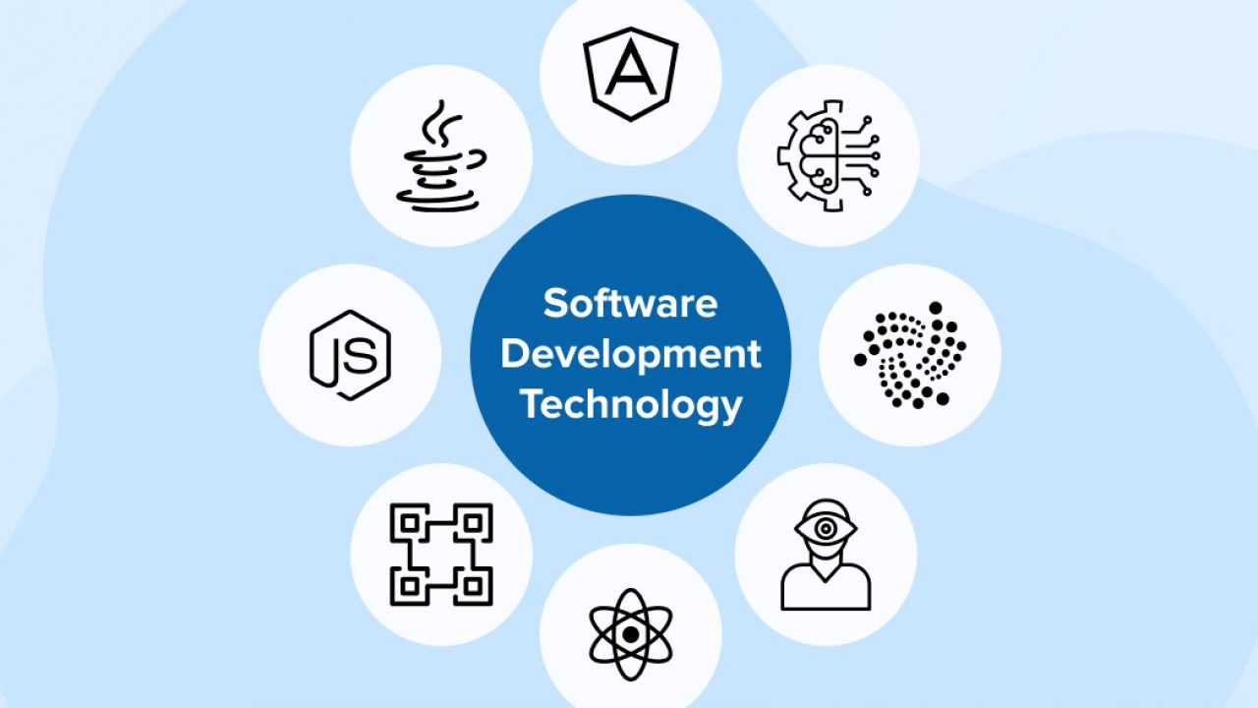

Fig 1.2 Company Technology Focus

**Chapter 2: Overview of Department and Process Being Carried Out in Company**

**2.1 Work Carried Out in Departments of Company**

Engineer Core have different departments and they are:

1. **Ethical Hacking:**

Ethical hacking involves legally breaking into computers and devices to test an organization's defenses.

Technologies Used:

* Penetration Testing Tools (e.g., Metasploit, Nmap): These tools simulate attacks on a network to identify vulnerabilities.
* Vulnerability Scanners (e.g., Nessus): These scanners detect and classify system weaknesses and potential security holes.
* Security Information and Event Management (SIEM) Systems: These systems provide real-time analysis of security alerts generated by applications and network hardware.

1. **Android App Development:**

Android app development involves creating applications for devices running the Android operating system.

Technologies Used:

* Android Studio: The official integrated development environment (IDE) for Android development, offering tools for coding, testing, and debugging.
* Kotlin/Java: Programming languages used to write Android applications, with Kotlin being the preferred modern language.
* Android SDK: A collection of development tools and APIs necessary for building, testing, and debugging Android applications.

1. **Blockchain:**

Blockchain is a decentralized ledger technology that ensures secure and transparent recording of transactions across multiple computers.

Technologies Used:

* Cryptographic Hash Functions (e.g., SHA-256): These functions ensure data integrity and security within the blockchain.
* Smart Contracts (e.g., Solidity for Ethereum): Self-executing contracts with the terms of the agreement directly written into code.
* Consensus Algorithms (e.g., Proof of Work, Proof of Stake): These algorithms ensure agreement among distributed network nodes on the state of the blockchain.

1. **Machine Learning:**

Machine learning is a branch of artificial intelligence that involves training algorithms to learn from and make predictions or decisions based on data.

Technologies Used:

* Machine Learning Frameworks (e.g., TensorFlow, PyTorch): These frameworks provide tools and libraries for building, training, and deploying machine learning models.
* Data Preprocessing Tools (e.g., Pandas, Scikit-learn): These tools are used to clean, transform, and prepare data for analysis.
* Algorithms (e.g., Decision Trees, Neural Networks, SVMs): These are mathematical models and processes used to perform tasks such as classification, regression, and clustering.

1. **Cloud Computing With AWS:**

Cloud computing with AWS involves using Amazon Web Services to deliver on-demand computing resources and services over the internet.

Technologies Used:

* Amazon EC2 (Elastic Compute Cloud): Provides scalable virtual servers to run applications, allowing for flexible computing capacity.
* Amazon S3 (Simple Storage Service): Offers scalable object storage for data backup, archival, and analytics.
* AWS Lambda: A serverless compute service that runs code in response to events and automatically manages the underlying compute resources.

1. **Frontend Development:**

It refers to the creation and management of the user interface and user experience elements of a website or application. This includes everything users see and interact with directly.

Technologies Used:

* HTML/CSS: Structure and style the content on web pages.
* JavaScript: Adds interactivity and dynamic behavior.
* Frontend Frameworks/Libraries: Tools like React, Angular, and Vue.js streamline development and enhance performance.

1. **MySQL:**

MySQL is an open-source relational database management system (RDBMS) that uses Structured Query Language (SQL) for database access and management.

Technologies Used:

* SQL (Structured Query Language): Used for querying and managing the database.
* InnoDB Storage Engine: Provides transaction-safe (ACID compliant) tables.
* Replication: Allows data from one MySQL database server to be replicated to another.

1. **Django:**

Django is a high-level Python web framework that promotes rapid development and clean, pragmatic design for building web applications.

Technologies Used:

* Python: The programming language in which Django is written and operates.
* ORM (Object-Relational Mapping): Allows developers to interact with databases using Python objects instead of SQL.
* Django Admin: A built-in administrative interface for managing application data and users.

**2.2 Systematic Layout for Manufacturing Web App**

A schematic layout for the sequence of operations in manufacturing an Android app involves outlining the key stages from conception to deployment. Here's a simplified schematic:

**1. Conceptualization and Planning**

- Define app purpose, features, and target audience

- Conduct market research and competitor analysis

- Create user personas and define user stories

**2. Design**

- Develop wireframes or mockups for app screens

- Design UI elements, including colors, fonts, and layout

- Create UX flow to ensure intuitive user interaction

**3. Development**

- Write code based on design and functionality specifications

- Implement front-end (UI) and back-end (logic, databases, APIs)

- Test code for bugs and functionality during development

**4. Testing**

- Conduct various tests: functional, usability, performance, etc.

- Address bugs and refine features based on test results

- Ensure compatibility across different Android devices and version

**5. Deployment**

- Prepare app listing for distribution platforms .

- Set up developer accounts and app signing

- Release app and monitor initial user feedback

**6. Maintenance and Updates**

- Monitor app performance and user feedback post-launch

- Address bugs and issues with regular updates

- Enhance features and optimize performance based on analytics

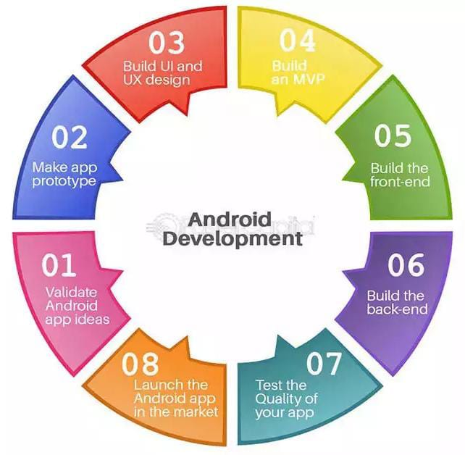

Table 2.1 Systematic Layout For Manufacturing Android

### Chapter 3: Introduction to Internship and Internship Management

### 3.1 Internship Summary

### Over the course of this internship, I had the opportunity to immerse myself in the dynamic field of web application development, focusing specifically on Web platforms. The internship aimed to enhance practical skills in various stages of app development, from conceptualization and design to implementation, testing, and deployment. This experience will impact on my professional growth and career aspirations in the field of Web app development.

### 3.2 Purpose

The purpose of the web development internship at **CodeInYourSelf** is to provide interns with an opportunity to apply theoretical knowledge in a practical setting, while gaining valuable industry experience. This internship aims to enhance interns' proficiency in full-stack web development, particularly using the HTML ,Css,JavaScript. By working on live projects, interns develop technical skills in areas such as responsive design, API integration, and database management.

In addition to technical growth, the internship focuses on professional development, encouraging collaboration through teamwork, version control, and communication within a dynamic environment. By fostering both personal and professional growth, the internship prepares interns for real-world challenges, equipping them with the skills and confidence needed to excel in the tech industry.

### 3.3 Objectives

### The main objectives are listed below:

### Skill Enhancement

### Career Acceleration

### Innovation and Creativity

### Industry Alignment

### Community Building

### This training programs aims to empower individuals to excel in Android app development, contribute meaningfully to the tech industry, and pursue rewarding career opportunities in mobile technology.

### 3.4 Scope

### The scope of the internship encompasses various aspects such as:

* **Diverse Roles**: Frontend developers can specialize in various roles such as UI/UX designers, web designers, or frontend engineers. Each role focuses on different aspects of creating visually appealing and user-centric web interfaces.
* **Growing Demand**: The rise of mobile devices, progressive web applications (PWAs), and responsive design has amplified the need for talented frontend developers who can create seamless, high-performance user experiences across multiple platforms.
* **Industry Versatility**: Frontend developers are sought after across a multitude of industries, including technology, finance, healthcare, e-commerce, and entertainment. This versatility allows developers to work in various sectors and choose the industry that aligns with their interests.
* **Creative and Technical Balance**: The role of a frontend developer combines creative design with technical skills. Developers work with languages like HTML, CSS, and JavaScript to bring designs to life while ensuring functionality, performance, and accessibility.
* **Freelance and Remote Opportunities**: The nature of frontend development allows for flexible work arrangements, including freelance positions and remote work. This flexibility can provide a better work-life balance and the opportunity to work with clients or teams globally.
* **Career Advancement**: With experience, frontend developers can advance to senior roles such as Lead Frontend Developer, Frontend Architect, or even transition into full-stack development. Additionally, specialization in emerging technologies like React, Angular, or Vue.js can enhance career prospects.
* **Continual Learning**: The rapidly evolving nature of web technologies means that frontend developers must engage in continuous learning. This constant evolution presents opportunities to stay at the cutting edge of technology and explore new tools and frameworks.

### 3.5 Internship Scheduling

### Week Wise Schedule

|  |  |
| --- | --- |
| Week 1 | Introduction, Installation of code editor, HTML basics, CSS basics,JavaScript Basic,Build a mini project by using HTMl and CSS |
| Week 2 | Responsive Design and Media Queries, JavaScript Dom manipulation, Introduction to Frontend Framework, Build a mini project by using HTMl , CSS, JavaScript |

### Table 3.1 Internship Scheduling

**Chapter 4: System Analysis**

### 4.1 Study of Current System

### The current system may include simple quiz applications or manual quiz methods like pen-and-paper quizzes. These systems lack dynamic and engaging features, making them less appealing and efficient for users.

### 4.2 Problems and Weaknesses of Current System

### Limited Functionality: Existing systems might only offer basic quiz-taking capabilities without interactive elements.

### Manual Grading: Quizzes often require manual grading, which can be time-consuming and prone to errors.

### User Engagement: Lack of engaging features to keep users motivated.

### Accessibility: Current systems might not cater to users with different accessibility needs.

### Data Management: Inefficient tracking of user progress and scores.

**4.3 Requirements of New System**

* **User-friendly Interface:** Simple and easy-to-navigate design.
* **Basic Interactivity:** Features like multiple-choice questions and instant feedback.
* **Automated Grading:** Immediate grading of quizzes to save time.
* **Data Storage:** Basic data storage for user scores and progress.
* **Accessibility:** Basic accessibility features to ensure usability for all users.

**4.4 System Feasibility**

**4.4.1 Does the system contribute to the overall objectives of the organization?**

* Yes, the system provides an accessible and engaging way for users to take quizzes, enhancing their learning experience.

**4.4.2 Can the system be implemented using the current technology?**

* Yes, the system can be developed using current Android development technologies such as Kotlin or Java, Android Studio and Firebase for backend services. These tools are free and widely supported, making them suitable for a beginner project.

**4.4.3 Can the system be integrated with other systems which are already in place?**

* Yes, the system can be designed to integrate with basic educational tools and platforms using standard APIs.

**4.5 Activities Carried Out in Proposed System**

* **User Registration:** Secure sign-up process of users.
* **User Authentication:** It processes the login activity.
* **Quiz Creation and Management:** Admin interface for creating and managing quizzes.
* **User Score Board:** User can see their quiz score.

**4.6 Features of Proposed System**

* **Multiple-choice Questions:** Simple format for quiz questions.
* **Instant Feedback:** Immediate feedback on quiz answers.
* **Score Display:** Display scores after quiz completion.
* **User Registration:** Basic user registration and login system.
* **Data Storage:** Store user scores and quiz data using Firebase or local storage.
* **Basic Accessibility:** Features like adjustable text size and simple navigation.

**4.7 List of Modules**

* **User Authentication Module:**

Handles user registration and login using Firebase Authentication.

* **Quiz Management Module:**

Allows admin to create and manage quizzes using Firebase Firestore.

* **Quiz Participation Module:**

Enables users to take quizzes and submit answers using *RecyclerView*.

* **Scoring and Progress Tracking Module:**

Automatically calculates scores and tracks user progress.

* **User Interface Module:**

Provides a simple and intuitive interface for navigation and interaction.

**4.8 Selection of Hardware and Software**

**Hardware**

* **User Devices:** Android smartphones and tablets
* Justification: The app targets Android users.
* **Development Devices:** Basic laptop or PC
* Justification: Sufficient for running Android Studio and testing the app.

**Software**

* **Android Studio:** IDE for Android development
* Justification: Standard and comprehensive tool for Android app development.
* **Firebase:** Backend services for authentication, database, and notification.
* Justification: Provides easy-to-use backend services for beginners.
* **Kotlin/Java:** Programming languages for Android development
* Justification: Official languages for Android, with Kotlin being beginner-friendly.

**Chapter 5: System Design**

**5.1 Use-Case Diagram**

Use case diagram provides a visual representation of the interactions between users (actors) and a system. It illustrates the system's functional requirements, showing what the system should do without detailing how these functions are implemented. Use case diagram help identify the various user types and their interactions with the system, ensuring that all functional requirements are captured during the design phase.

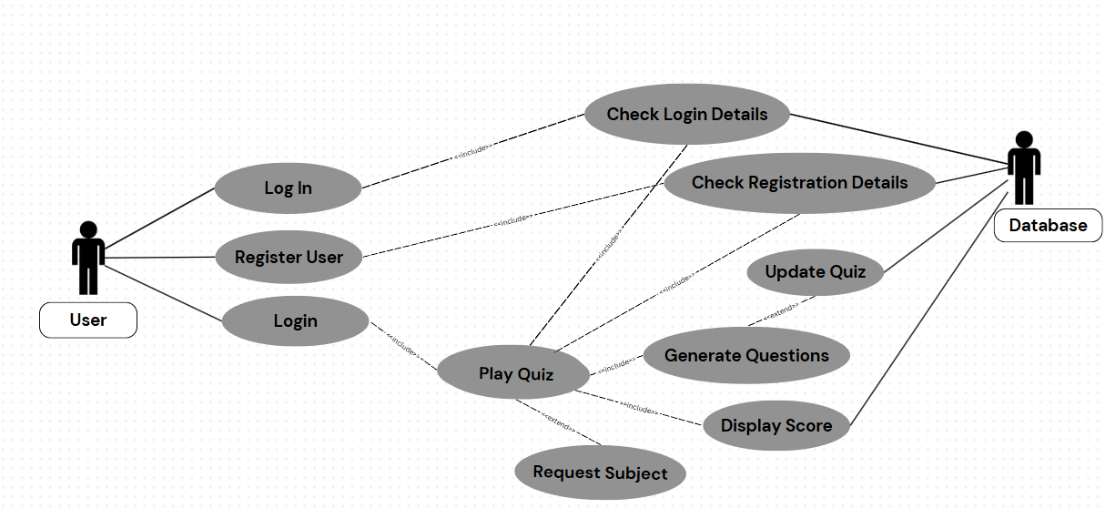

Fig 5.1 Use Case Diagram

**5.2 Activity Diagram**

Activity Diagrams are used to illustrate the flow of control in a system and refer to the steps involved in the execution of a use case. It shows the sequence of tasks (activities/actions), decision points, transitions (arrows indicating flow), and start/end nodes.

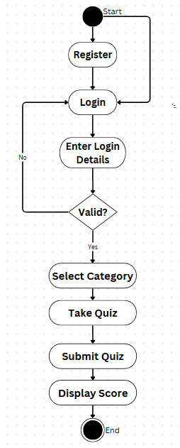

Fig 5.2 Activity Diagram

**Chapter 6: Implementation**

* 1. **Implementation Platform**

1. **Android Studio :**

[With Android Studio, developers can build high-quality applications for the Android platform, leveraging features like Gradle-based build support, Android-specific refactoring, a rich layout editor, and support for multiple programming languages including Java, C++, and Kotlin](https://www.techopedia.com/definition/33631/android-studio).

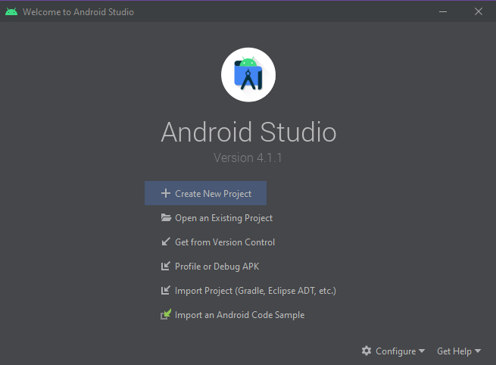

Fig 6.1 Android Studio

1. **Firebase :**

[It offers a range of backend cloud computing services, including databases, authentication, and integration for various platforms](https://en.wikipedia.org/wiki/Firebase).

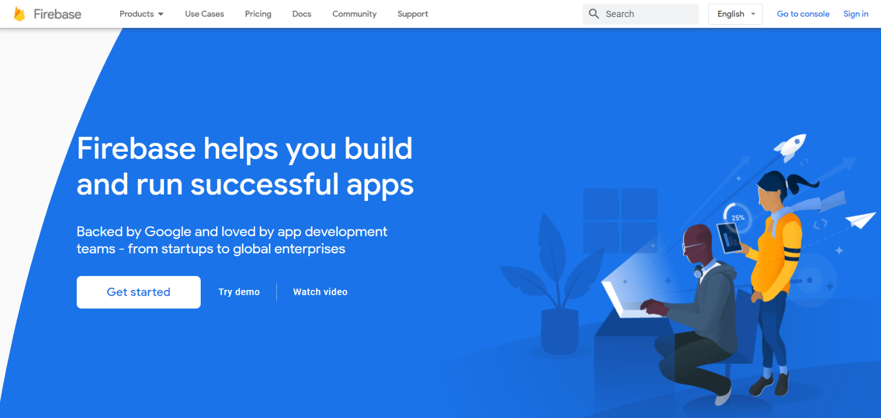

Fig 6.2 Firebase

* 1. **Project Outcome**

**Quiz App**

* Signup Page:

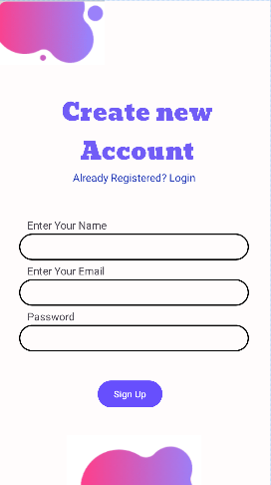

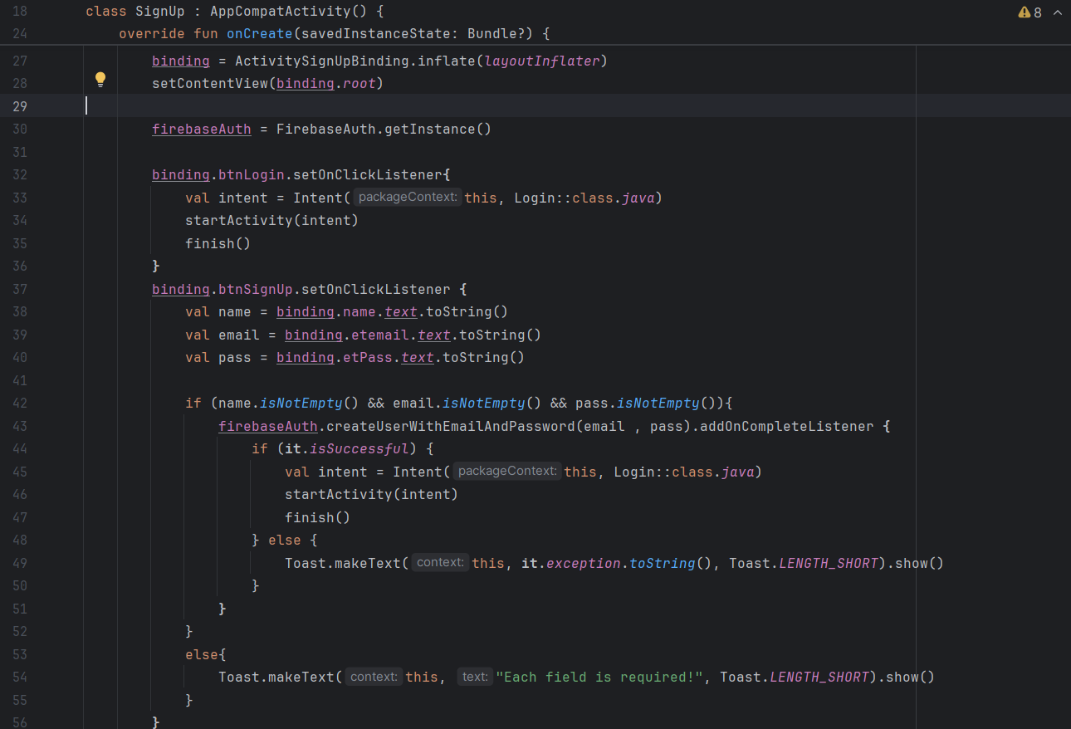

Fig 6.3 Signup Page and Code

* Login Page:

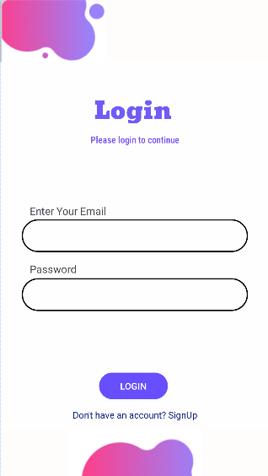

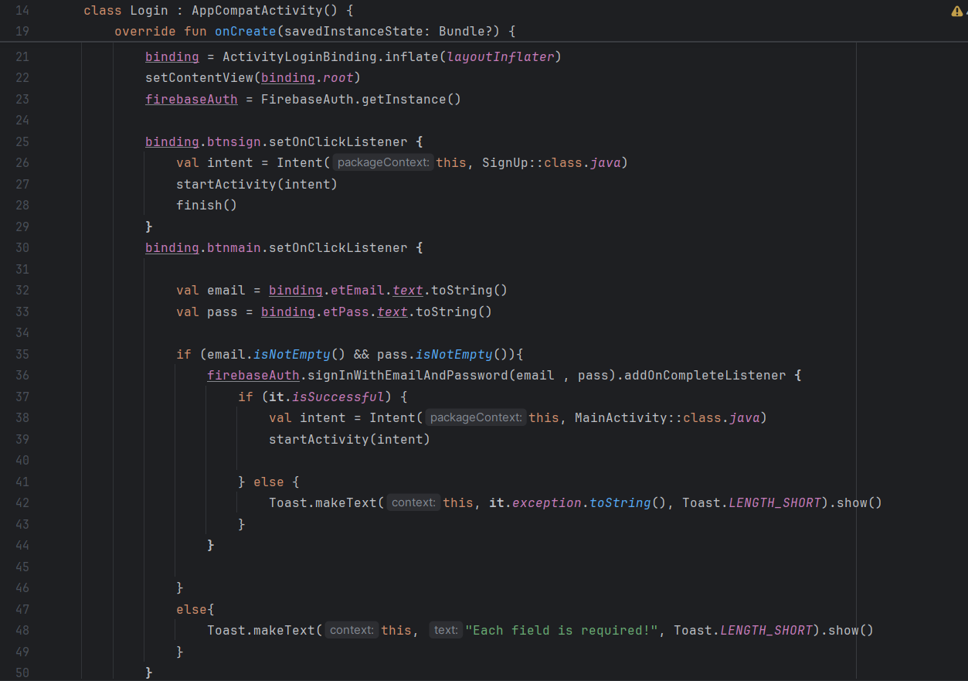

Fig 6.3 Login Page and Code

* Main Activity:

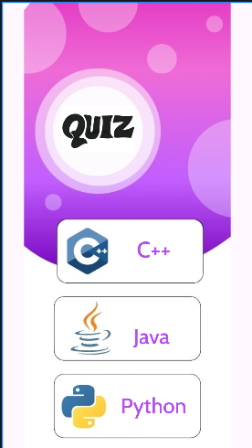

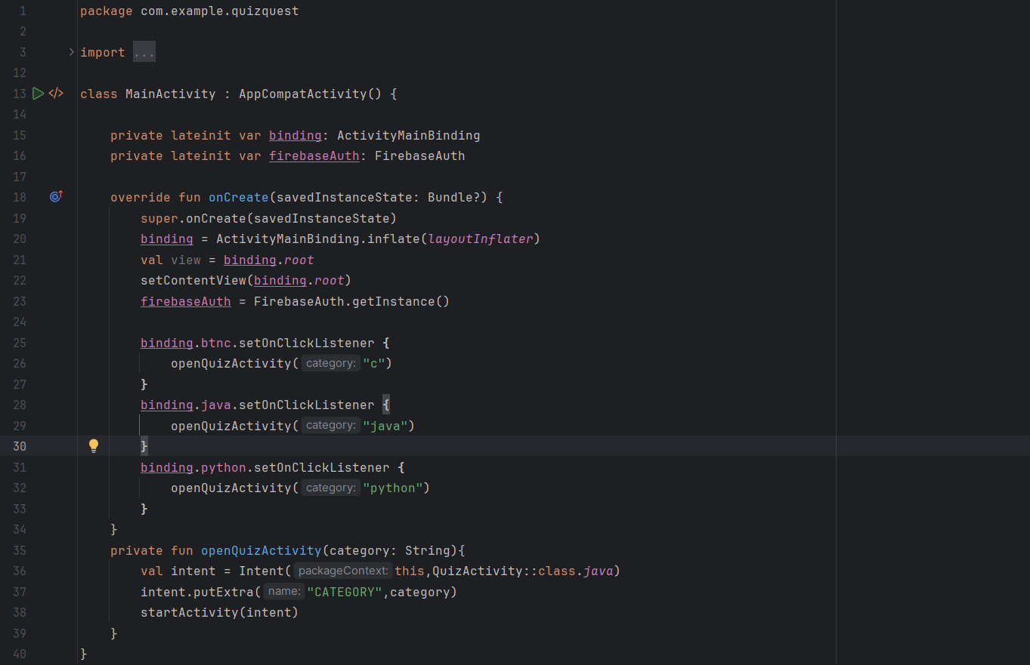

Fig 6.3 Main Activity Page and Code

* 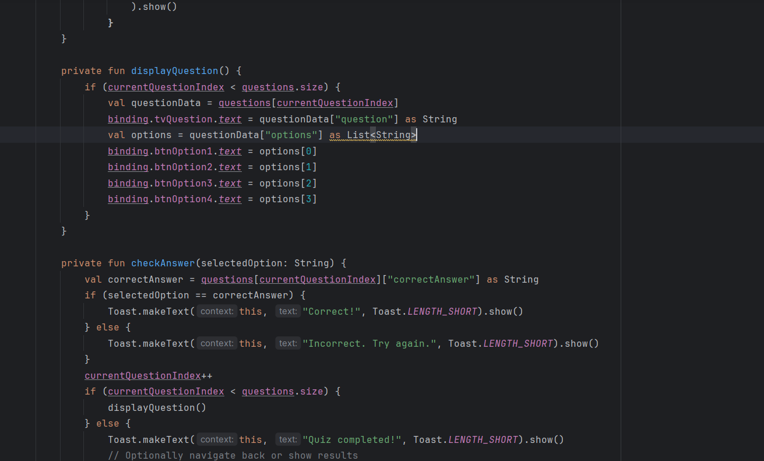Quiz Page:

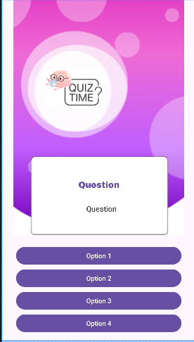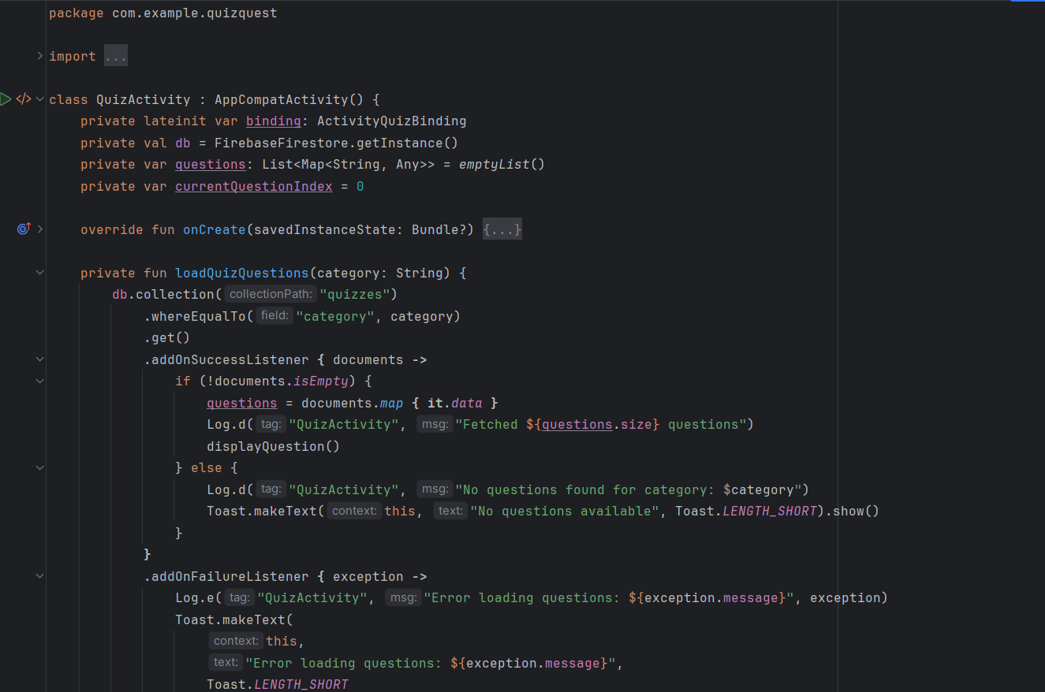

Fig 6.4 Quiz Page and Code

**Chapter 7: Conclusion**

The internship at **CodeInYourSelf** has been a transformative and enriching experience, providing me with invaluable hands-on experience in frontend web development. Over the past weeks, I have significantly expanded my technical skills and professional understanding in key areas such as HTML, CSS, JavaScript, and modern frontend frameworks like React.Throughout this internship, I had the opportunity to work on practical projects that challenged me to apply my knowledge in real-world scenarios. This exposure to live project environments helped me refine my abilities in coding, debugging, and optimizing web applications. By contributing to various aspects of web development, from designing responsive layouts to implementing interactive features, I have gained a comprehensive understanding of the frontend development lifecycle.Additionally, working closely with the team at **CodeInYourSelf** allowed me to enhance my collaboration skills, learn industry best practices, and adapt to dynamic project requirements. The mentorship and feedback I received were instrumental in my growth, providing me with insights into effective problem-solving and professional development.In conclusion, this internship has not only equipped me with practical skills and experience but also deepened my passion for web development. I am confident that the knowledge and skills gained will serve as a solid foundation for my future career in frontend web development. I am grateful for the opportunity to contribute to **CodeInYourSelf** and am excited to apply what I have learned in future projects and professional endeavors.

**Chapter 8: References**

* [**https://developer.android.com/**](https://developer.android.com/)
* [**https://javascript.info/**](https://javascript.info/)
* **https://github.com/topics/website-template**
* **https://developer.mozilla.org/en-US/**
* [**https://www.geeksforgeeks.org**](https://www.geeksforgeeks.org)